How to add the College shared Calendars to your Outlook Client

First launch Outlook. Click on the calendar icon, then the three dots to the right and click on “Folders:”

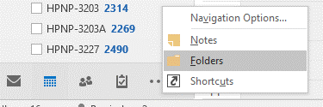

Scroll down in the folders list on the left hand side until you see “public folders - *your email address*.” Use the arrows on the left of each title to expand out:

Expand out the Public folders
Expand out All Public folders
Expand out HSC
Expand out Nursing

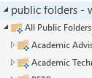

Now there should be a list of calendars and folders for the College of Nursing:

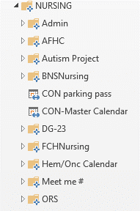
From there you will need to find the calendar you want to add. Conference rooms are located in the Admin folder.

If you want to add the CON-Master Calendar for example you right click on the calendar and Add to favorites, then Click Add:

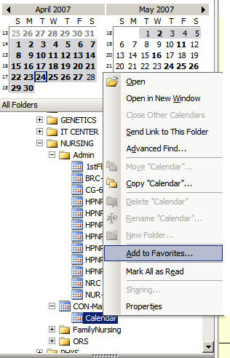

Go back into the Calendar view in Outlook.
Under Other Calendars you should see the calendar you just added.
To view the calendar just put a check mark next to the calendar you would like to view.

